Peter Victoratos

CSC 411

Lab08 Template Matching Writeup

1. Results for Normalized Cross Correlation

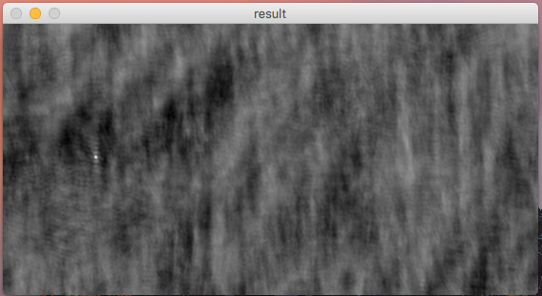

1. Found Waldo!

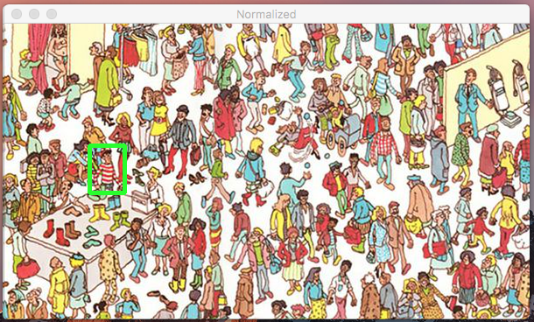

3. Non-Normalized Results/Not Finding Waldo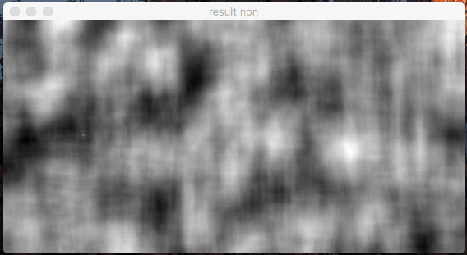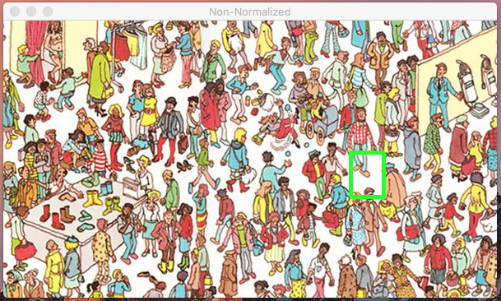

In the non-normalized image results there is a lot of white all throughout the image. Although Waldo’s true location is visible there is a large white spot towards the right of the image. I believe the bounding box goes to this region because it is already a really bright spot (the whitest spot in the image).

4. Different Waldo Scene Results and Not Finding Waldo

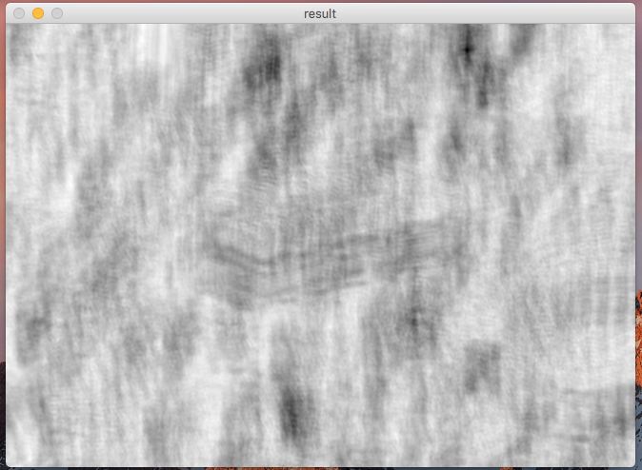

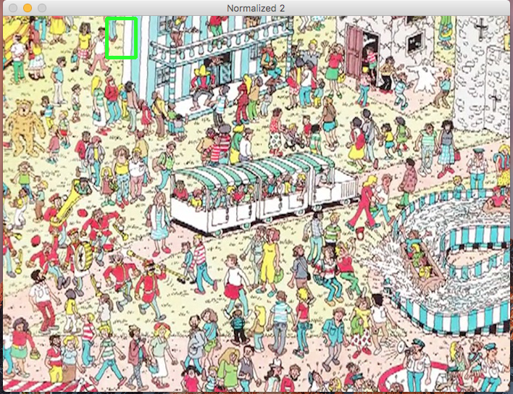

Since the template we used was from the other image, it would have been pretty much impossible to find newly posed Waldo. He also has a much different background compared to the original Waldo. Since the template doesn’t really fit in anywhere in the image, the image captured the region with the highest value instead (really bright yellow and white).